Final Project Milestone #4

CIS 9440 - Data Warehousing for Analytics

Final Project Milestone 4

Group Number - 21

Student(s) - Leah Lu, Porfirio Mohabir, Eric Sedaghat, Tori Torsaengtong, Tshering Sherpa

1. List your final set of 3-5 KPI’s.

* Change in Listing Price year over year
* Max Listing price each year
* Change in Income year over year
* Median Income per City by Household Type
* Median days on market

1. Short description of Visualization that will be used for each KPI. Why will you use that type of visualization?

|  |  |
| --- | --- |
| KPI’s | Visualization |
| Change in Listing price year over year | Highlight table - focusing on the percentage change each year from 2017-2021 based on city and zipcode. We used highlight tables here because it draws our attention to the darker highlights, which are the values with the highest change in property value. |
| Max Listing price each year | Bar graph - comparing the areas that have the most expensive property value each year. Using the bar graph, we can see which city had the highest property value each year. |
| Change in Income year over year | Color Text table - The table shows the Percent change in median income per year (2017,2018,2019) by city. Using the red-green colorway, the KPI visualization provides a very clear visual of big/small percent changes over time. |
| Median Income per City by Household Type | Line graph - comparing the areas that have the most income by household types. Each line in the graph shows the household type’s income in that city, not only can we see which areas have a higher income, but which household type has the higher income. We can use this to invest in specific property types. For example, individuals without kids may be more interested in buying apartments or families with kids may be more interested in one/two family houses. |
| Median days on market | Bar graph - showing average median days on market from zip codes that have the most to the least days. We used a bar graph because it allows us to easily spot the highest/lowest bars that can be used to identify which zip codes have the highest / least days on market. |

1. Paste a picture of your BI Application Wireframe (hand drawn image, google draw, any other format).

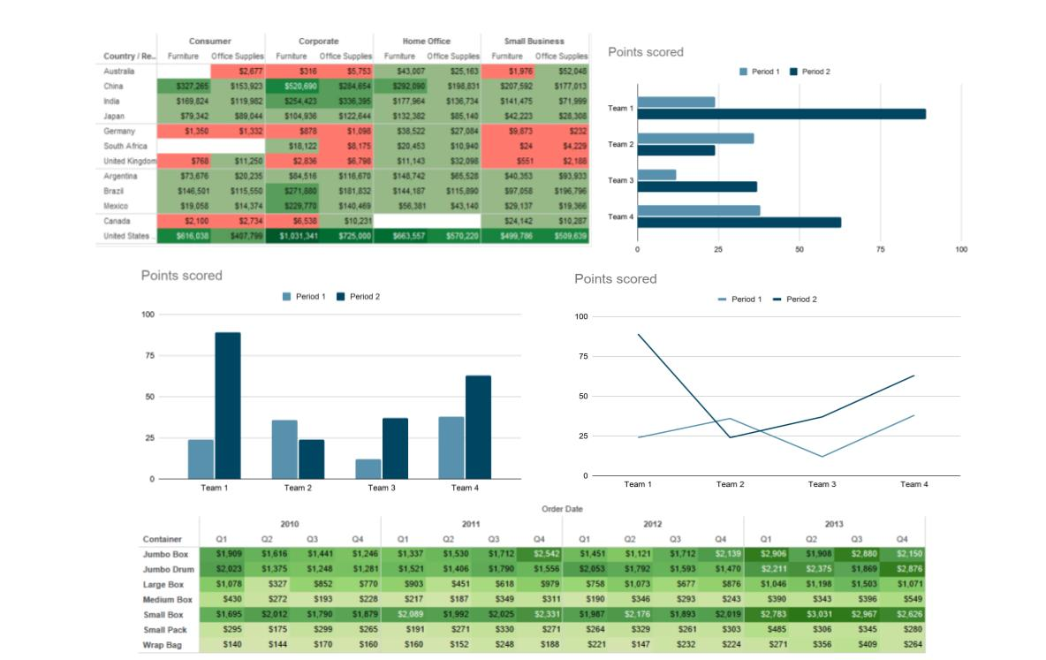

1. Link to your Tableau Public dashboard. (ensure this link works!)

<https://public.tableau.com/profile/tshering.sherpa#!/vizhome/CIS9440-Milestone4-Group21/Dashboard1>